What is eRegistrations?
eRegistrations is a no-code development platform allowing swift development of eGovernment applications through which users of the public service can request online simultaneous registration with various government agencies, with one single form, a single set of documents and a single payment.
- Analysts can configure online services without coding (in a module called Business Process Analyzer) and, once ready, publish them to the public part of the system (called Display System)
- Users can apply to the online services through the public app.

Technical stack
The eRegistrations microservices have been created using a variety of technologies that have been carefully chosen to match the requirements of each individual system. Current technologies are as follow:
- Programming languages and frameworks: Java, Python, Nodejs, React, Angular
- Storage systems: PostgreSQL, MongoDB, Elastic
- Development and deployment tools: All micro-services running inside Docker containers which come with the following benefits:
  - Isolation
  - Easy deployment
  - Host independent
- Orchestration of services: through docker swarm/docker compose/kubernetes

System components
eRegistrations is a microserviced system which comes with the following benefits:
- Independent modular services
- Loosely coupled services organized around business requirements
- Precise scope of each component
- Communication through a well-defined, technology-agnostic mechanism
- Services can use any given technology
- Usage of as many open-source and battle-tested modules as possible, some in-house services

Here are the tools used in the eRegistrations stack - all are open source:
- Camunda - workflow process engine to manage the flow of a file
- Formio - service used for defining, rendering and validating forms.
- Keycloak - authentication and authorization system.
- Mule - service bus to connect to external web-services.
- Restheart - Rest API platform used to store all service configurations.
- ActiveMQ - message queue system to facilitate micro services communication.
- Graylog - log management system
- ClamAV - antivirus system used to scan user uploads

The diagram below shows an overview of the entire stack and how components interacts with each other
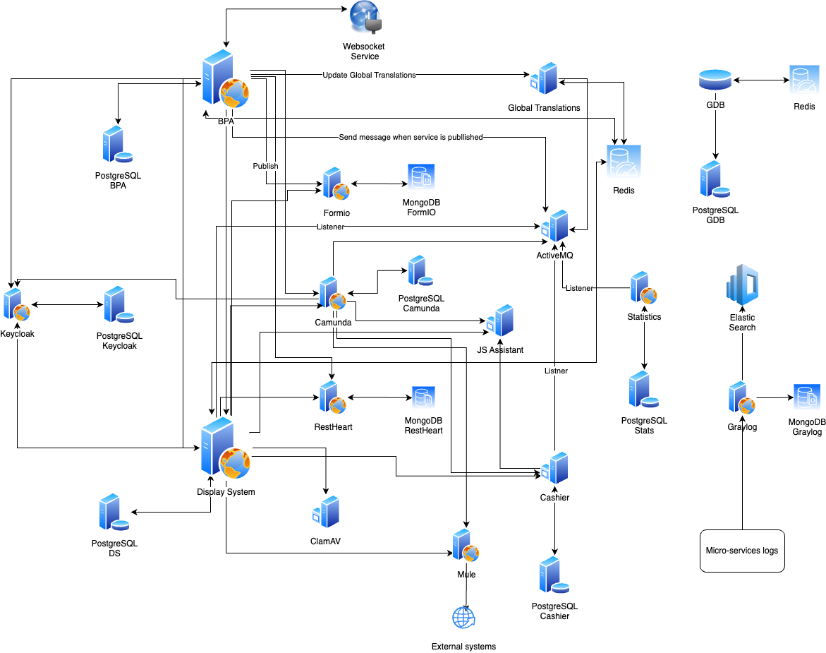

Other useful resources
- More about eRegistrations security here.
- DS technical documentation here
- BPA technical documentation here

